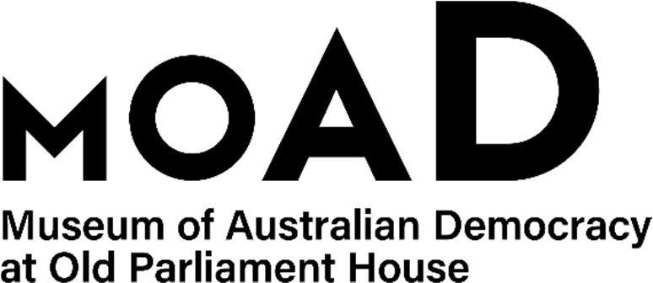

CANDIDATE PACK

|  |  |
| --- | --- |
| **POSITION DETAILS** | |
| **Reference No** | 21920 |
| **Title** | Museum Experience Officer |
| **Classification** | APS Level 3 |
| **Employment Type** | Non-ongoing for 6 months with possibility of extension or ongoing |
| **Working Hours** | Part Time (49 hours) per fortnight roster |
| **Salary** | $64,523 - $70,506 + 15.4% superannuation + 21.5% commuted penalties  The salary range will increase on 13 March 2025 to $66,975 - $73,185 |
| **Section** | Museum Experience, Learning and Operations |
| **Team** | Museum Experience |
| **Eligibility** | Australian Citizen, Baseline security clearance & a Working with Vulnerable People (WwVP) registration card prior to commencement. |
| **Contact Officer** | Trent Winter-Perry (02 6270 8241) |
| **Opening Date** | Friday 14 February 2025 |
| **Closing Date** | Sunday 2 March (11:59pm) |
| **Special Note** | **This is a non-ongoing opportunity for 6 months with the possibility of ongoing or extension.**  Suitable candidates may be placed in a merit pool from this selection process and the pool may be used to fill similar ongoing or non-ongoing roles. Non-ongoing vacancies filled from a merit pool may be offered as a specified term. Applicants may have their application and assessment results shared with other Australian Public Service (APS) agencies looking to fill similar roles. |

# POSITION DETAILS

The position of Museum Experience Officer, in the Museum Experience team, is responsible for providing high quality customer service and the delivery of engaging programs to a diverse public.

The position is the first point of contact for visitors, responsible for providing information on the Museum and its events and programs, as well as cloaking services, Point-of-Sale (POS) services, and other reception duties.

The role requires the ability to learn, develop, and deliver public programs and presentations and involves long periods of standing and moving throughout the Museum.

# DUTIES

Under the general supervision of the Volunteers and Museum Experience Supervisors, this position will:

* Provide high quality interactions with museum visitors, including entry management, providing information about the Museum, and promoting programs, retail services and telephone calls.
* Provide services for the operation of the Museum’s retail shop.
* Assist in the development of and provide the facilitation and support of a range of public programs, tours, events, and activities. Occasional after-hours work may be required.
* Assist in providing direction to volunteers and help to facilitate the museum’s volunteer program.
* In association with other museum teams, support compliance with agency security and heritage requirements, and monitor exhibition functionality.
* Develop productive working relationships with colleagues, volunteers and other stakeholders that add value to service delivery.
* Provide general support to the Museum Experience team and management, including assisting with project work and gathering visitor feedback.

# OUR IDEAL CANDIDATE

Our ideal candidate will possess:

* Strong interpersonal skills and demonstrated ability to work in a diverse team in a customer service environment.
* Experience with Point of Sale (POS) systems and cash handling, Microsoft Office, booking systems, volunteer management and rostering programs would be an advantage.
* Demonstrated ability to show initiative, share knowledge, take on constructive feedback and take responsibility for personal development.
* A flexible and positive approach to learning new things.
* Interest and knowledge of, or the ability to quickly acquire, an understanding of Australian politics and history.
* The ability to deliver engaging tours and public programs, using public speaking, interpretation, and presentation skills.

**ELIGIBILITY**

Employment with the Museum of Australian Democracy is subject to the following conditions:

* **Citizenship** – To be eligible for employment with MoAD, applicants must be an Australian Citizen.
* **Security Clearance** – The successful applicant will be required to obtain and maintain a security clearance at the baseline level.
* **Working with Vulnerable People (WwVP) –** The successful applicant will be required to obtain a WwVP card prior to commencement.

# ROSTER

This position works 7 hours per day on a fixed 7-day roster pattern (see table below), including regular weekend shifts and some public holidays. You will receive 21.5% commuted penalties in addition to your base salary each fortnight.

In addition, the successful applicant may occasionally be required to work overtime to support operations outside of their rostered hours. Penalty rates will apply for any hours worked in addition to standard hours.

|  |  |  |  |  |  |  |  |
| --- | --- | --- | --- | --- | --- | --- | --- |
|  | **Thurs** | **Fri** | **Sat** | **Sun** | **Mon** | **Tues** | **Wed** |
| **Week 1** |  |  |  |  | 7.0 | 7.0 |  |
| **Week 2** |  |  | 7.0 | 7.0 | 7.0 | 7.0 | 7.0 |

# YOUR APPLICATION

* Please provide a concise statement of claims of no more than 1 page.
* When framing your statement, please ensure you adequately demonstrate your skills, qualifications and experience against the duty statement and key attributes for this position.
* Resume outlining your career history, qualifications and contact details for at least two recent referees (no more than 2 pages)
* MoAD Application Cover sheet

# SUBMISSION OF APPLICATION

Your application should be submitted by the closing date to  [applications@moadoph.gov.au](mailto:applications@moadoph.gov.au)

* Your application will be automatically acknowledged. If you do not receive an automated receipt, please contact the Recruitment Officer on 02 6270 8192 or 02 6270 8235
* Applications received after closing will not be accepted unless prior arrangement has been made with the contact officer.
* RecruitAbility applies to this vacancy. Under RecruitAbility you will be invited to participate in further assessment activity for the vacancy if you choose to apply under RecruitAbility; declare you have a disability; and meet the minimum requirements for the position. For more information visit the [APSC website](https://www.apsc.gov.au/working-aps/diversity-and-inclusion/disability/recruitability).
* MoAD accommodates requests for reasonable adjustment for people with disabilities to participate in an interview, including offering onsite tours to potential employees before their interviews to gauge any possible access barriers and to comfortably see staff spaces before committing to interview or the job position. Please indicate this in your coversheet or contact the recruitment officer on 02 6270 8192 or 02 6270 8235.