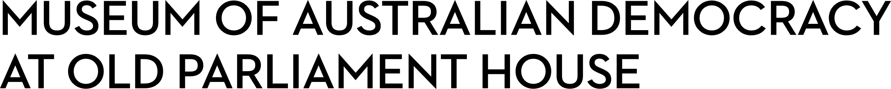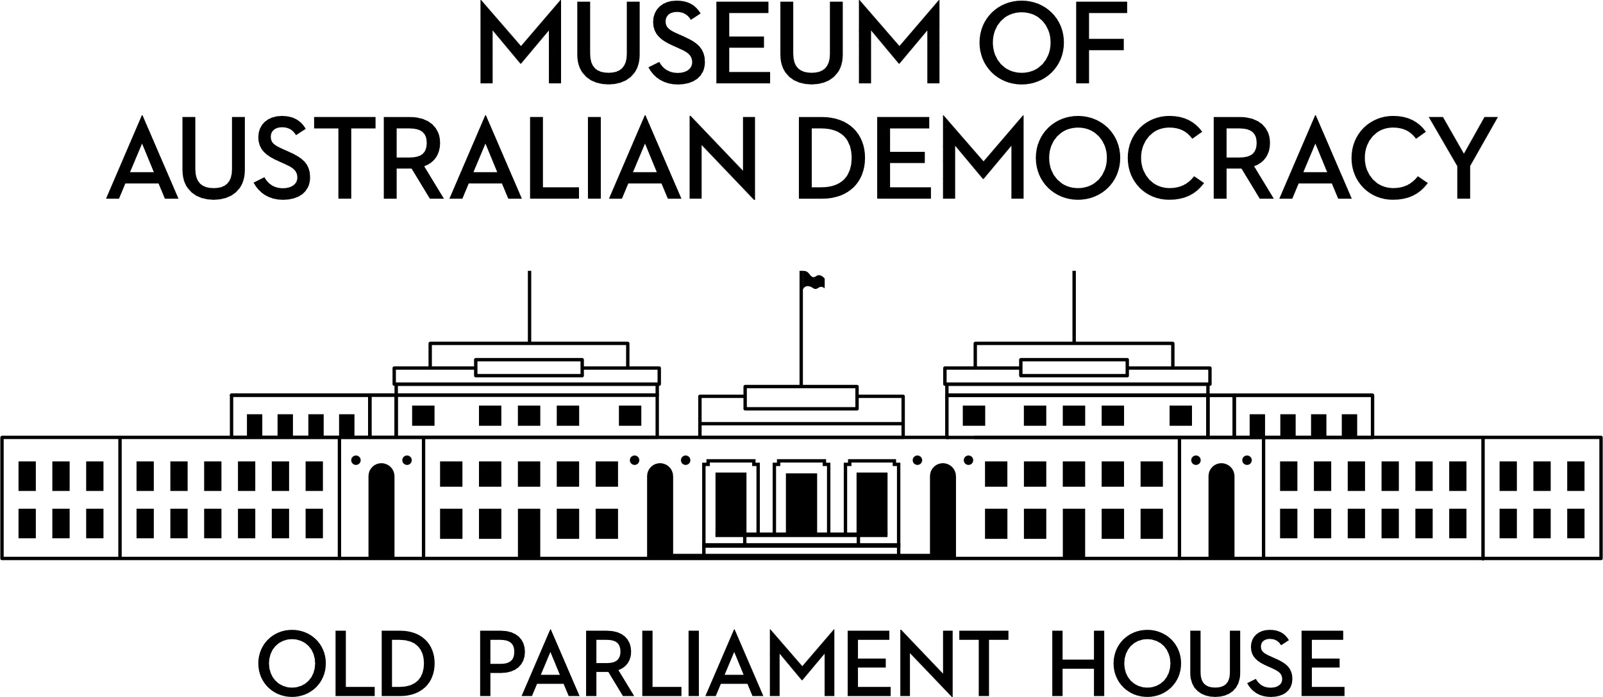

**CANDIDATE PACK**

|  |  |
| --- | --- |
|  | |
| **POSITION DETAILS** | |
| **REFERENCE NO** | Several Positions |
| **TITLE** | Centenary Projects Curatorial Staff Multiple positions APS4 - APS 6 level |
| **CLASSIFICATION** | APS Level 4  APS Level 5  APS Level 6 |
| **EMPLOYMENT TYPE** | Non-Ongoing Specified Task |
| **WORKING HOURS** | Full-time |
| **OFFICE ARRANGEMENT** | On-site with work from home considered |
| **SALARY** | APS 4 - $75,385 - $81,775 pa + 15.4% Superannuation  APS 5 - $84,229 - $91,808 pa + 15.4% Superannuation  APS 6 - $94,563 - $105,910 pa + 15.4% Superannuation |
| **SECTION** | Curatorial and Interpretation |
| **TEAM** | Roles are offered across two teams within the Curatorial and Interpretation Section:   * Interpretation and Content Development * Research Collections and Curatorial |
| **ELIGIBILITY** | * Australian Citizenship * Security Clearance (after commencement) |
| **CONTACT OFFICER** | Ashley Tenison  02 6270 8148 |
| **OPENING DATE** | Friday 8th August 2025 |
| **CLOSING DATE** | Monday 25th August 2025 11:59pm |
| **SPECIAL NOTE** | **These are non-ongoing Specified Task opportunities until the end of the centenary program in late 2027.**  Suitable candidates may be placed in a merit pool from this selection process and the pool may be used to fill similar non-ongoing roles. Non-ongoing vacancies filled from this merit pool may be offered as a specified task. |

**ABOUT US**

The Museum of Australian Democracy (MoAD) at Old Parliament House is a contemporary museum located in a heritage-listed building that was home to Australia's Parliament from 1927 to 1988.

True to our building’s original brief, we provide a ‘people’s place’, where big ideas are explored.

We share the story of Australia's democracy through exhibitions, events and education programs, as well as through our rich online collection of stories, objects and resources.

At MoAD, we celebrate the Australian democratic journey. We seek to provoke thought and inspire conversation by sharing stories and objects that played a part in shaping the nation as it is today.

Careers at MoAD are varied, from human resource officers, exhibition curators, heritage officers and learning facilitators, to digital producers, finance officers and IT specialists. We are a small agency, working in a dynamic environment, sharing our democratic and political history in a heritage-listed building.

MoAD is an inclusive and rewarding workplace that values the contributions of all our staff. We encourage applications from First Nations Australians, people with a disability, culturally and linguistically diverse people and LGBTQIA+ people. We are committed to a safe and supportive workplace which includes flexible working practices. MoAD’s commitment to reconciliation is expressed in the [MoAD Reconciliation Action Plan 2023-25](https://www.moadoph.gov.au/sites/default/files/2023-06/MoAD%20INNOVATE%20RAP_2023.pdf).

MoAD employees are engaged under the [*Public Service Act 1999*](https://www.legislation.gov.au/C2004A00538/latest/text) and are subject to the terms and conditions of employment in the [*OPH Enterprise Agreem**ent 2024-2027*](https://moadoph.gov.au/sites/default/files/2024-04/oph-enterprise-agreement-2024-2027.pdf)*.*

**POSITION DETAILS**

**The positions**

Old Parliament House will mark its centenary in 2027 and MoAD is developing a suite of programs for the anniversary.

We are recruiting curatorial staff at APS 4, APS 5 and APS 6 levels to support the development and delivery of content for exhibition and interpretation projects and for web, social media and digital interactives. Positions will support the delivery of centenary projects and ongoing operations during this period of increased activity.

We are recruiting for five positions:

* APS 4 – Assistant Curator (1 position)
* APS 5 – Assistant Curator (1 position)
* APS 6 – Curator (3 positions)

As an Assistant Curator or Curator you will work in the Curatorial and Interpretation Section with specialist staff. You’ll know how to research and tell a great story. You will be skilled at working with people from all walks of life. You’ll have an aptitude for exhibition and curatorial work, and be organised and proficient at administration.

**ROLE RESPONSIBILITIES and DUTIES**

**APS 4 Assistant Curator (1 position)**

The APS 4 Assistant Curator will be responsible for supporting exhibition projects.

Supported by a Curator/Senior Curator, the APS 4 Assistant Curator will:  

* Carry out focused research using MoAD’s collection, materials from other institutions, and input from stakeholders, including the general public.
* Assess the provenance, cultural context and significance of objects that might be featured in MoAD exhibitions or added to the collection.
* Work collaboratively with internal teams and external contacts and professionally represent MoAD.
* Support curatorial work through excellent record keeping including updating database information, organising research materials, managing object lists, and keeping track of stakeholders.
* With support from senior staff, write and review exhibition content and other materials for onsite and online visitors.

**APS 5 Assistant Curator (1 position)**

The APS 5 Assistant Curator will be responsible for leading and supporting exhibition and interpretation projects.

Working under limited direction from the Curator/Senior Curator, the APS 5 Assistant Curator will:  

* Develop and deliver exhibition and interpretive content for onsite and online visitors.
* Carry out focused research using MoAD’s collection, materials from other institutions, and input from stakeholders, including the general public.
* Assess the provenance, cultural context and significance of objects that might be featured in MoAD exhibitions or added to the collection.
* Work collaboratively with internal teams and external contacts and professionally represent MoAD.
* Represent MoAD at a range of public forums and in the print, radio, television and online media.

**APS 6 Curator (3 positions)**

There are three APS 6 Curator positions:

* one position will lead exhibition projects
* one position will lead the content development for MoAD’s exhibition changeover program
* one position will work collaboratively with the Digital team to research, develop and review content for digital outputs including the web, social media and digital interactives for exhibitions.

Under limited direction from the Senior Curator, an APS 6 Curator will undertake projects that are complex in nature. An APS 6 Curator appointed to any of the above positions will be required to:

* Lead curatorial and/or interpretation projects; this may include (but is not limited to) the development and delivery of content for an exhibition or online output (e.g. web, social media) or managing a program of gallery changeovers.
* Under limited direction, develop and deliver exhibition content, online features, and other materials for visitors.
* Review and advise on colleagues’ outputs to achieve high quality results.
* Lead focused research using MoAD’s collection, materials from other institutions, and input from stakeholders, including the general public.
* Assess the provenance, cultural context and significance of objects that might be featured in MoAD exhibitions or added to the collection.
* Work collaboratively with internal teams and external contacts and professionally represent MoAD.
* Represent MoAD at a range of public forums and in the print, radio, television and online media.
* Manage staff members at the APS 4 and 5 levels including devising work plans, setting priorities and handling workflows (depending on team staffing).

**OUR IDEAL CANDIDATE**

The ideal candidates for these positions are storytellers who enjoy working with people, objects and settings to create engaging experiences for onsite and online museum visitors.

The qualities that we are seeking for each position are outlined below:

**APS4 Assistant Curator**

* Demonstrated research skills in Australian history, museum studies, or a related discipline.
* Knowledge and interest in Australian political, social, and democratic history.
* Excellent organisational skills, an ability to set and manage priorities, and flexibility. An ability to complete tasks in a timely and thorough manner.
* Demonstrated and well-developed communication skills.
* Demonstrated ability to work in a team and with different types of stakeholders.
* Ability to use a range of applications including standard ICT tools – including Microsoft Word and Microsoft Outlook – and an ability and willingness to learn new software.

* A basic working knowledge of KE EMu database would be an advantage.

**APS5 Assistant Curator**

* Tertiary qualifications and a strong interest in Australian social, political and democratic history, museum studies, or a related discipline are highly desirable.

* Excellent organisational skills and an ability to set and manage priorities, and complete tasks in a timely and thorough manner.
* Demonstrated and well-developed communication skills.
* Demonstrated ability to work in a team and with different types of stakeholders.
* Ability to think creatively to solve problems, to be flexible in your approach and to deliver high quality work.

* Ability to support and provide advice and guidance to less experienced colleagues as required.

* Ability to use a range of applications including standard ICT tools – including Microsoft Word and Microsoft Outlook – and an ability and willingness to learn new software.

* A basic working knowledge of KE EMu database would be an advantage.
* Prior experience working in a gallery, library, museum or archive is highly desirable.

**APS 6 Curator**

* Tertiary qualifications and a strong interest in Australian social, political and democratic history, museum studies, or a related discipline are highly desirable.
* Demonstrated ability to work with limited direction to develop and deliver exhibition or interpretation projects or related work programs.
* Excellent organisational skills, an ability to set and manage priorities, and flexibility. An ability to complete tasks in a timely and thorough manner.
* Demonstrated and well-developed communication skills.
* Demonstrated ability to work in a team and with different types of stakeholders.
* Ability to think creatively to solve problems, to be flexible in your approach and to deliver high quality work.

* Ability to support and provide advice and guidance to less experienced colleagues. Ability to manage staff and team workflows, if required.
* Ability to use a range of applications including standard ICT tools – including Microsoft Word and Microsoft Outlook – and an ability and willingness to learn new software.

* A basic working knowledge of KE EMu database would be an advantage.
* Prior experience working in a gallery, library, museum or archive is highly desirable.

**YOUR APPLICATION**

Please provide a:

* concise statement of claims of no more than 2 pages. When framing your statement, please ensure you adequately demonstrate your skills, qualifications, experience and capabilities.
* Resume outlining your career history, qualifications and contact details for at least two recent referees (no more than 4 pages).
* coversheet from the [MoAD Website](https://www.moadoph.gov.au/about/careers).   
  Please note: when you complete the coversheet please indicate which role/s you are applying for.

MoAD accommodates requests for reasonable adjustment for people with disabilities to participate in an interview, including offering onsite tours to potential employees before their interviews to gauge any possible access barriers and to comfortably see staff spaces before committing to interview or the job position. Please indicate this in your cover sheet or contact the recruitment officer on 02 6270 8235 or 02 6270 8127.

**ELIGIBILITY**

To be eligible for this position at MoAD, applicants must:

* be an Australian Citizen; and
* have a security clearance or be willing to undertake the process to obtain a baseline clearance (after commencement).
* be willing to provide identity documents and undergo an identity pre-employment check through a Document Verification Service, if you are deemed to be the successful candidate.

**SUBMISSION OF APPLICATION**

Your application should be submitted by the closing date to [applications@moadoph.gov.au](mailto:applications@moadoph.gov.au)

For noting:

* Your application will be automatically acknowledged. If you do not receive an automated receipt, please contact 02 6270 8235 or 02 6270 8127 or email [recruitment@moadoph.gov.au](mailto:recruitment@moadoph.gov.au)
* Applications received after closing will not be accepted unless a prior arrangement has been made with the contact officer