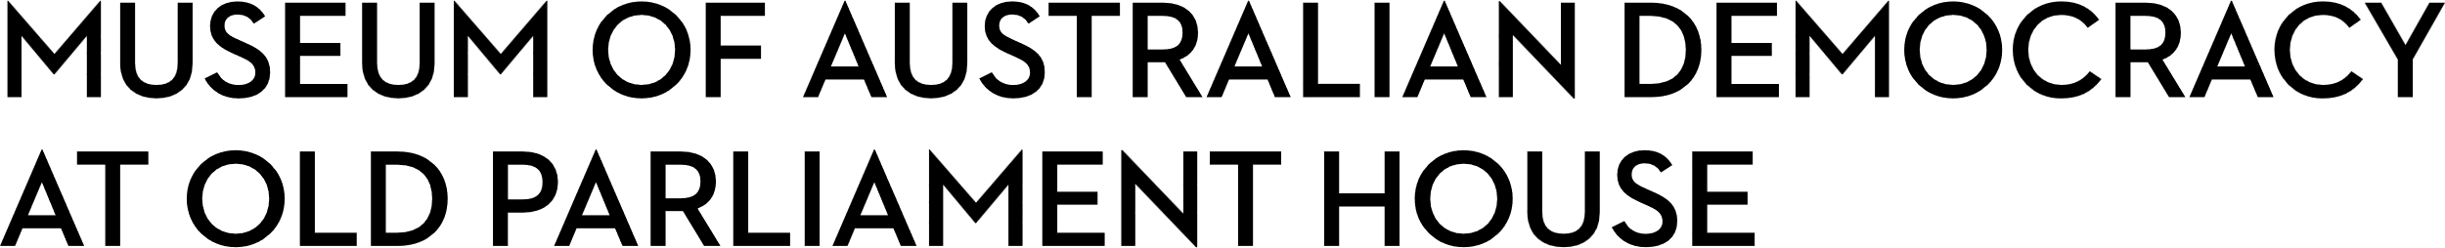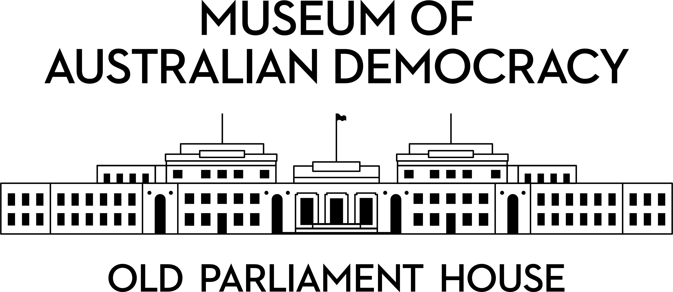

**CANDIDATE PACK**

|  |  |
| --- | --- |
|  | |
| **POSITION DETAILS** | |
| **REFERENCE NO** | 31109 |
| **TITLE** | Manager Built Heritage |
| **CLASSIFICATION** | Executive Level 1 |
| **EMPLOYMENT TYPE** | Ongoing |
| **WORKING HOURS** | Full-time |
| **OFFICE ARRANGEMENT** | On-site with work from home considered |
| **SALARY** | $115,443 - $125,832 pa + 15.4% Superannuation |
| **SECTION** | Capital Projects and Built Heritage |
| **TEAM** | Built Heritage |
| **ELIGIBILITY** | * Australian Citizenship * Baseline Security Clearance (after commencement) |
| **CONTACT OFFICER** | Bernard Finucane [Bernard.finucane@moadoph.gov.au](mailto:Bernard.finucane@moadoph.gov.au) |
| **OPENING DATE** | Monday 25 August 2025 |
| **CLOSING DATE** | Sunday 7 September 2025 11:59 pm |
| **SPECIAL NOTE** | **This is an ongoing opportunity.**  This role may be filled using applications and referee reports only.  Suitable candidates may be placed in a merit pool from this selection process and the pool may be used to fill similar ongoing or non-ongoing roles. Non-ongoing vacancies filled from a merit pool may be offered as a specified term.  Applicants may have their application and assessment results shared with other Australian Public Service (APS) agencies looking to fill similar roles. |

**ABOUT US**

The Museum of Australian Democracy (MoAD) at Old Parliament House is a contemporary museum located in a heritage-listed building that was home to Australia's Parliament from 1927 to 1988.

True to our building’s original brief, we provide a ‘people’s place’, where big ideas are explored.

We share the story of Australia's democracy through exhibitions, events and education programs, as well as through our rich online collection of stories, objects and resources.

At MoAD, we celebrate the Australian democratic journey. We seek to provoke thought and inspire conversation by sharing stories and objects that played a part in shaping the nation as it is today.

Careers at MoAD are varied, from human resource officers, exhibition curators, heritage officers and learning facilitators, to digital producers, finance officers and IT specialists. We are a small agency, working in a dynamic environment, sharing our democratic and political history in a heritage-listed building.

MoAD is an inclusive and rewarding workplace that values the contributions of all our staff. We encourage applications from First Nations Australians, people with a disability, culturally and linguistically diverse people and LGBTQIA+ people. We are committed to a safe and supportive workplace which includes flexible working practices. MoAD’s commitment to reconciliation is expressed in the [MoAD Reconciliation Action Plan 2023-25](https://www.moadoph.gov.au/sites/default/files/2023-06/MoAD%20INNOVATE%20RAP_2023.pdf).

MoAD employees are engaged under the [*Public Service Act 1999*](https://www.legislation.gov.au/C2004A00538/latest/text) and are subject to the terms and conditions of employment in the [*OPH Enterprise Agreem**ent 2024-2027*](https://moadoph.gov.au/sites/default/files/2024-04/oph-enterprise-agreement-2024-2027.pdf)*.*

**POSITION DETAILS**

Reporting to the Head – Capital Projects & Built Heritage, the Manager Built Heritage will play a key role in the successful delivery of the Museum’s ongoing capital works program to ensure compliance with the [*Old Parliament House and Curtilage Heritage Management Plan (2021- 26)*](https://www.moadoph.gov.au/sites/default/files/2023-01/MoAD-Heritage-Management-Plan-2021-26.pdf) and the *OPH Heritage Strategy*.

This position will be part of a team responsible for the planning and delivery of capital works, with a focus on heritage training, compliance and planning for major capital works.

**ROLE RESPONSIBILITIES and DUTIES**

Under direction from the Head – Capital Projects & Built Heritage, the Manager Built Heritage will be expected to:

* Lead a small team to fulfil the Agency’s responsibility to identify, protect, conserve, present and transmit, the heritage values of Old Parliament House in relation to capital projects.
* Provide written and verbal advice on all capital projects to achieve Agency objectives in harmony with the place’s heritage values. Ensure works are guided by HMP policy, heritage and corporate strategies and delivered according to the established MoAD procedures and are consistent with the Environment Protection and Biodiversity Conservation (EPBC) Act.
* Manage the input from the Capital Projects & Built Heritage team to Actions Committee including reviewing documentation for accuracy and completeness. Provide approval for all Project Records. Review and advise on consultant plans, documentation and reporting.
* Provide strategic input into the Capital works program and activities for the Old Parliament House building.
* Identify and implement opportunities for continuous improvement of heritage practice, policies and systems, including updates of the HMP and associated plans and strategies.
* Provide high level reporting to key stakeholder groups such as the Heritage Actions Committee, Project Steering Committee, Board and the Annual Report.
* Develop, coordinate and maintain stakeholder relationships to achieve desired outcomes, this includes external agencies such as the National Capital Authority and the Department of Climate Change, Energy the Environment and Water for approvals or other liaison as may be required.
* Work collaboratively with the Head – Capital Projects & Built Heritage and across MoAD, providing strategic leadership to the Built Heritage team and other Section team members to promote team cohesion, performance improvement and a commitment to quality.

**OUR IDEAL CANDIDATE**

Our ideal Candidate will have:

* Extensive demonstrated knowledge of research, processes, protocols and legislation relating to the conservation and management of heritage listed buildings, including the EPBC Act and heritage management plans.
* Tertiary qualifications in cultural heritage management or related discipline and a minimum of 7 years’ practical experience working in cultural and built heritage management is highly desirable.
* Results-oriented approach with track record for collaborative problem solving and achieving results within multi-disciplinary project teams.
* Well-developed communication (written and oral), presentation and interpersonal skills. including. ability to prepare high quality and accurate documents and reports,
* Adroit stakeholder management skills and a demonstrated ability to liaise with people at a number of different levels.
* Well-developed organisational and time-management skills, with the ability to determine priorities and exercise sound judgement and initiative.
* Strong collaborative approach to customer service, team leadership, the ability to work well across the organisation and maintain productively working relationships.
* Proficiency in the use of the digital asset management systems and the MS suite of products, such as Project, Excel, Word and Outlook.

**YOUR APPLICATION**

Please provide a:

* concise statement of claims of no more than 2 pages. When framing your statement, please ensure you adequately demonstrate your skills, qualifications, experience and capabilities.
* Resume outlining your career history, qualifications and contact details for at least two recent referees (no more than 4 pages).

MoAD accommodates requests for reasonable adjustment for people with disabilities to participate in an interview, including offering onsite tours to potential employees before their interviews to gauge any possible access barriers and to comfortably see staff spaces before committing to interview or the job position. Please indicate this in your cover sheet or contact the recruitment officer on 02 6270 8235 or

02 6270 8127.

**ELIGIBILITY**

To be eligible for this position at MoAD, applicants must:

* + be an Australian Citizen; and
  + have a security clearance or be willing to undertake the process to obtain a baseline clearance (after commencement).
  + be willing to provide identity documents and undergo an identity pre-employment check through a Document Verification Service, if you are deemed to be the successful candidate.

**SUBMISSION OF APPLICATION**

Your application should be submitted by the closing date to [applications@moadoph.gov.au](mailto:applications@moadoph.gov.au)

For noting:

* Your application will be automatically acknowledged. If you do not receive an automated receipt, please contact 02 6270 8235 or 02 6270 8127 or email [recruitment@moadoph.gov.au](mailto:recruitment@moadoph.gov.au)
* Applications received after closing will not be accepted unless a prior arrangement has been made with the contact officer